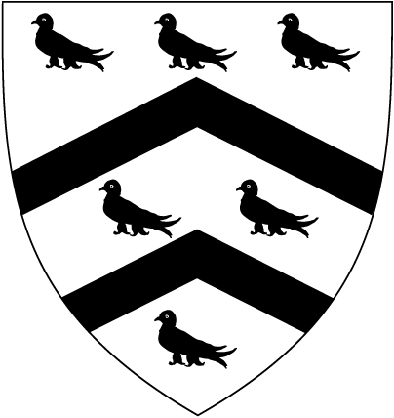  WORCESTER  COLLEGE  OXFORD | DIVERSITY  DECLARATION FORM

We are committed to being an Equal Opportunities employer and ask that you complete this form if you are applying for a position at Worcester College.

We wish to ensure that all applicants are treated fairly and appointed solely on their suitability for the post irrespective of race, gender, age, disability, caring responsibilities, sexual orientation, marital / civil partnership status, religion / belief or nationality. The College treats personal data collected for reviewing equality of opportunity in recruitment, selection and, if relevant, employment within the College in accordance with its data protection policy. Information about how your data is used and the basis for processing is provided in the College’s job applicant privacy notice (http://www.worc.ox.ac.uk/about/policies-and-procedures/privacy-gdpr).

We are sensitive to the fact that some people would rather not complete diversity forms - either because they fear the information will be misused, or because they consider some of the questions to be highly personal. We would like to put your mind at rest. We can assure you that the information given is kept separately from the information used in recruitment decisions. The information will not be used to influence recruitment decisions and all information is strictly confidential, PURELY for statistical purposes and to ensure that policies are being applied fairly. The reference at the top of the page identifies the post and date of advertisement, so that we know the year and month in which the data was collected, which assists with analysis.

We will not discriminate against individuals who decide not to complete the form. However, we ask that as many people as possible agree to help us measure diversity – because it matters to us.

Please answer the questions by completing or ticking the appropriate box.

GENDER Male  Female  Non-binary 

AGE

16-24  25-29  30-34  35-39  40-44  45-49  50-54 

55-59  60-64  65+  prefer not to say 

ARE YOU MARRIED OR IN A CIVIL PARTNERSHIP? Yes  No  prefer not to say 

DISABILITY

Do you consider yourself to have a disability or health condition?
Under the Equality Act 2010 the definition of being disabled is if you have a physical or mental impairment that has a ‘substantial’ and ‘long-term’ negative effect on your ability to do normal daily activities. ‘Substantial’ is more than minor or trivial, e.g. it takes much longer than it usually would to complete a daily task like getting dressed; ‘long-term’ means 12 months or more. If you are diagnosed with HIV infection, cancer or multiple sclerosis you would automatically meet the disability definition under the Equality Act.

Yes  No  prefer not to say 

ETHNICITY
Ethnic origin is not about nationality, place of birth or citizenship. It is about the group to which you perceive you belong. Please tick the appropriate box below or, if you prefer not say, please tick this box 

White

English  Welsh  Scottish  Irish  British 

Gypsy or Irish Traveller  Any other white background (please specify): ………………….

Mixed/multiple ethnic groups

White and Black Caribbean  White and Black African  White and Asian 

Any other mixed background (please specify): …………………………………………………………..

Asian/Asian British

Indian  Pakistani  Bangladeshi  Chinese 

Any other Asian background (please specify): ……………………………………………………………

Black/ African/ Caribbean/ Black British

African  Caribbean 

Any other Black/African/Caribbean background (please specify): ………………………………………

Other ethnic group

Arab  Any other ethnic group (please specify): ………………………………………………….

SEXUAL ORIENTATION
How would you describe your sexual orientation?

Heterosexual  Gay woman/lesbian  Gay man  Bisexual 

prefer not to say  Other (please specify): ……………………………………………………..

RELIGION OR BELIEF

No religion or belief  Buddhist  Christian  Hindu  Jewish 

Muslim  Sikh  Other religion or belief (please specify): ………………………………..…

prefer not to say 

Thank you for taking the time to complete this form. You have helped us monitor our on-going commitment to treating everyone fairly - according to their ability, and nothing else.

Please return the form by email to recruitment@worc.ox.ac.uk or, if submitting a paper application, place it in a sealed envelope addressed to Human Resources, Worcester College, Oxford, OX1 2HB.

